IT24100150

Lab 05

01)

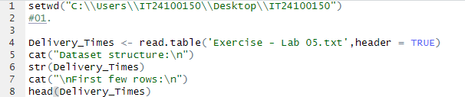

02)

03)

04)

